Euler’s Method.
Q. Write a program in python to demonstrate Euler’s Method.
Aim: To write a program in python to demonstrate Euler’s Method.
Program:

def f(x, y):

return x + y #

Example differential equation: dy/dx = x + y

main program
if name == "main":

x0 = 0.0 # initial x y0 = 1.0 # initial y h = 0.1 # step size
n = 5 # number of steps

print("="*70)
print(f"{'Euler\'s Method Approximation':^70}") print("="*70)
print(f"{'x':>8} {'y':>15}")

for i in range(n):
y1 = y0 + h * f(x0, y0) print(f"{x0:8.4f} {y0:15.6f}") x0 += h
y0 = y1

print(f"\nApproximate value of y({x0:.1f}) = {y0:.6f}") Result:

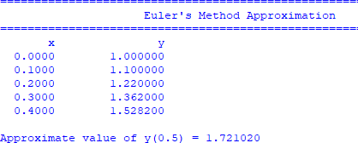

Conclusion: The above program has been executed successfully.

